SeniorCircle

Lo-fi Prototype and Usability Testing

*Annie N. | Cyrus D. | Steven G. O.*

## Introduction

### Value Proposition

Building community in care homes through teamwork!

### Mission Statement

We aspire to mitigate feelings of loneliness and isolation in care home residents by encouraging them to engage with one another in collaborative tasks that strengthen their community.

### Problem & Solution Overview

From interviewing multiple people who live in care homes, we learned that they often struggle to make connections with other residents and feel a sense of community. In the care home environment, seniors regularly spend a lot of time alone in their rooms. This leads to loneliness, frustration, and depression. Our app, SeniorCircle, encourages residents to turn that frown upside down!

SeniorCircle groups residents of complementary ability levels to accomplish a team task which overall contributes to a larger community goal. For example, folks can clean the lounge, fold napkins, or pour drinks all in service of a fun Happy Hour. In this way, residents of care homes get out of their rooms, interact with each other, and feel some synergy!

## Concept Sketches

|  |
| --- |
| Figure 1: Top - An interactable digital panel on the wall, acting as a friendly voice assistant  Bottom - A wearable watch app that detects nearby teammates in accomplishing a goal |

|  |
| --- |
| Figure 2: A mobile app with a map feature to visually track progress, teams, and tasks |

|  |
| --- |
| Figure 3: Top - A wearable hat that would visually indicate various states (have a task, done with task, etc.)  Bottom - A more visually oriented mobile app that responds to voice |

|  |
| --- |
| Figure 4: Top - A full sound system installed in rooms, responding to voice commands  Bottom - A idea for a wearable attached to the user’s chest that would project image and use biometric data |

|  |
| --- |
| Figure 5: Top - A mobile design involving various pages (team, progress, help chat)  Bottom - A speech-based wearable that has a simple button interface |

## Top Two: Storyboards

### AR-onman (AR Interface)

|  |
| --- |
| Figure 6: An AR interface that would visually indicate fellow teammates, tasks to do around a space, and have a virtually projected assistant |

### SeniorCircle Tasker

|  |
| --- |
| Figure 7.1: The first few pages of the design, checking in on the user, showing an assigned task, team page, progress map, call for help page, and options to continue |

|  |
| --- |
| Figure 7.2: Additional pages for sample preference questions |

### 

### AR-onman (AR Interface)

| **Pros** | **Cons** |
| --- | --- |
| * Requires people to interact to find their match * Add interest to the space where they live * Makes clear what the criteria for the task are (cleaning the lounge = folding blanket, straightening shelf, etc.) * Tech could have other uses that are also cool * Fun * Cannot lose it * Makes you feel like a superhero | * Hard to implement * Requires pretty decent sight * Would require major learning curve for residents * Requires that residents all wear glasses/something on their face * Less focus on the end goal |

**SeniorCircle Tasker**

| **Pros** | **Cons** |
| --- | --- |
| * Simpler * Looking at one screen at a time is much easier to handle * Is portable (on phone) and doesn’t obstruct daily activity * Easy to carry * Generally accessible (cost, portability, availability, leverages existing accessibility tech) * Less extreme learning curve | * The only interaction is when you are doing the task * Requires everyone to have a device * Requires people to touch the phone correctly * Easy to lose/forget * Repetitive * Less interactive/in reality in comparison to AR |

Our team ultimately decided on the SeniorCircle Tasker App, citing practicality and general accessibility as two key advantages. Seniors already commonly use mobile devices and introducing drastically new technology would be difficult to learn. Additionally, smartphones can take advantage of pre-existing standards, including accessibility features for individuals with disabilities and best practices for user experience design.

## 

## Lo-fi Prototype

Our lo-fi prototype is a mobile app that users navigate via a touchscreen. Users tap buttons (indicated by a black shadow) to interact with the device. The interface is novel in its focus on simplicity: a linear path, limited choices, and one consistent look for interactable elements.

In designing it, our team sketched out page designs on paper and uploaded them onto the Marvel POP app. Using the app’s tools, we wired up the task flows using button interactions. All participants had access to mobile devices and were able to access the prototype on their device.

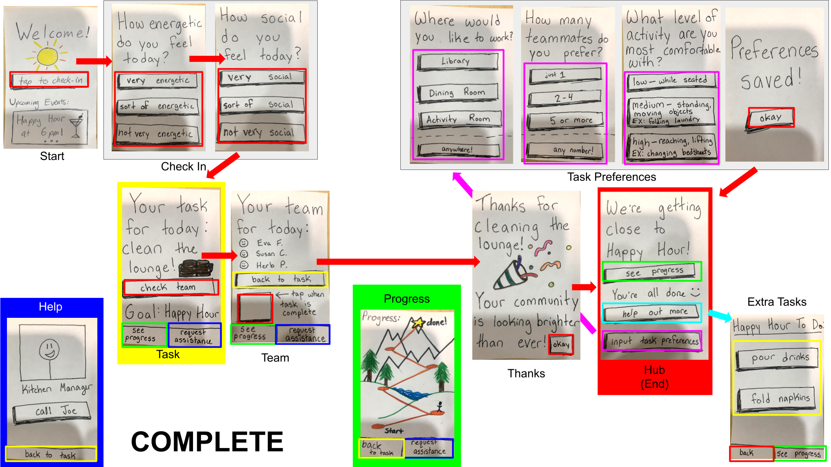

| Figure 8: Every screen of the lo-fi prototype, and how to move between them |
| --- |

|  |
| --- |
| Figure 9: Task flow for finding your task and completing it |

|  |
| --- |
| Figure 10: Task flow for requesting staff assistance |

|  |
| --- |
| Figure 11: Task flow for inputting task preferences (magenta) and for selecting extra tasks (cyan) |

## Testing Methodology

### Participants & Environment

We recruited a variety of participants focusing on seniors of varying technological abilities. Participant 1 works and lives in a care home, giving us insight into both sides as a senior user and familiarity with proposed users. Participant 1 has Parkinson’s and is mildly incompetent with the smartphone. Participant 2 volunteered and knew many residents in a care home. Participant 2 displayed a proficient facility with technology. Participant 3 also knew many residents in care homes and spent many days there with family and friends. Participant 3 was largely incompetent with the smartphone.

We conducted our tests through Zoom calls while the participants tried the prototype on their smartphones and provided commentary. Participants were not compensated, and were recruited through the researchers’ family connections.

### Tasks

Simple: Identify your task and mark it as complete

Moderate: Call for staff assistance

Complex: Input your preferences for future tasks; choose an additional task

### Usability Goals

We decided to concentrate on the robustness and efficiency of our prototype. We tried to support the user with a few clear options so they would not get lost. We also made the format simple and easy to understand to minimize any confusion.

### Procedure

Our facilitator presented the participants with the scenario that they live in a care home and are looking for something to do. He led the participants through their day, prompting them to interact with the app as they thought appropriate. The facilitator also asked them to think out loud and elaborate on some key phrases. The other two team members observed and took notes. Because our prototype was online in Marvel POP, we did not have anyone filling the role of Computer. After the participant completed all tasks, we invited them to share any additional thoughts they had about our prototype.

### Key and Other Test Measurements

* Does the participant get lost? If so, how often?
* Can they find their way out?
* How long did the participant take to complete the task?
* How many button taps did the participant make to complete the task?

### Team Member Roles

Annie: Observer & Notetaker

Steven: Greeter & Facilitator

Cyrus: Notetaker & Observer

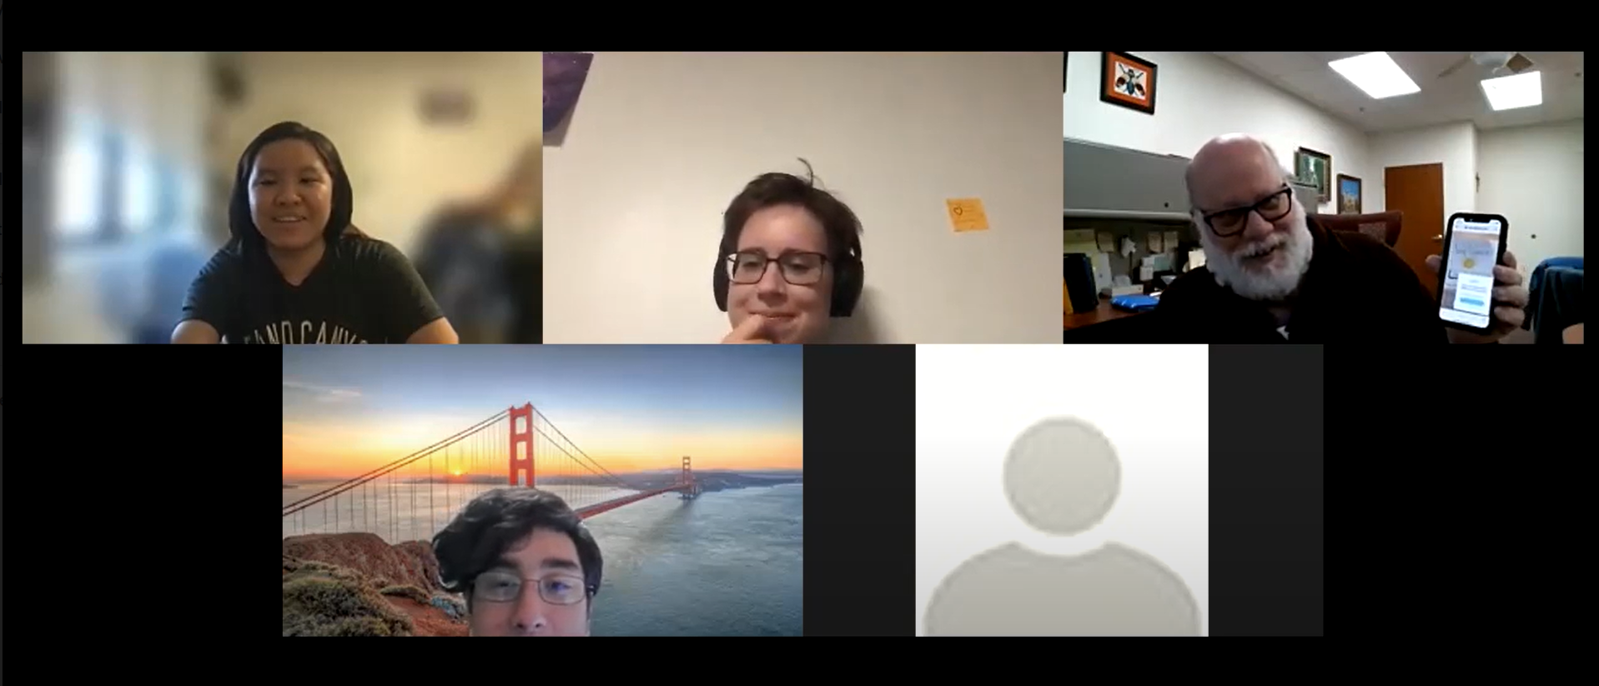

| Figure 12: Our Lo-fi prototype test on Zoom using Marvel POP |
| --- |

## Results

In our three usability tests, we obtained valuable feedback regarding how to improve our app.

* Participants did not understand that Happy Hour was the goal of all the tasks
* Needed more explanatory text on how to navigate the app
* The linear form with few options made it easier to stay on track
* How to accomplish some tasks was not obvious to some participants
* One participants asked if you use buttons on the side of the phone instead of tapping the screen
* Users responded well to the quiz format — simple and easy to do
* The progress meter was thought to be more focused on the individual instead of the community
* Participants reacted positively to the cheerful images and prompts

### Suggested UI Improvements

* More emphasis on what will happen next, e.g. add animations, colors, and sounds
* Create “user manual” for the app
* Make residents’ names buttons to communicate with them
* More positive reinforcement
* Distinguish more clearly what is a button and what is not
* Emphasize the community more than the individual on the progress page

## Discussion

Our usability tests confirmed our assumptions and surprised us in many ways.

The participants quickly understood the purpose of the app, and focused on finding and completing their task. The quiz format of the check-in came easily to the participants and engaged them in a dialogue with the app. Their enthusiastic reactions to our lighthearted illustrations and reassuring comments signaled us to bolster these features in later versions. Additionally, our linear format with few choices helped participants mostly avoid getting lost.

Nevertheless, we did receive constructive criticism. The progress screen misled all three participants. No one understood its purpose for *community* progress, rather than individual progress; some did not figure it out at all. We will improve this by adding clearer labels, such as “Community Progress,” and by changing the background picture to represent progress as a team.

We were also surprised that participants did not understand that the buttons (and *only* the buttons) were meant to be clicked. One participant asked if he should use the power and volume buttons to control the app, while another attempted to click on teammate names. This supported our assumption that it is necessary to clearly indicate what is interactable. However, we underestimated how clearly we needed to distinguish the buttons.

Our testing shows that our instincts took us in the right direction, but we still have much progress to make. We overlooked some small details that we incorrectly assumed our participants would not notice. We learned to aim to *over*emphasize and guide more transparently. In a future prototype, we hope to explore the effect of color, animation, and/or sound as tools for emphasis and clarity. Now we are equipped with astute insights and meaningful improvements to advance our project!

**APPENDICES**

## Appendix A: Critical Incident Logs

### Participant 1

| **Event** | **Severity of Problem**  **(0 = not a problem -> 4 = most severe)** |
| --- | --- |
| Difficulty understanding prototype interface, got it after some prompting | 2 |
| Smoothly went past check in questions | 0 |
| Wandered around a few pages before checking off task, didn’t get too lost | 1 |
| Quickly found the assistance button | 0 |
| “I need a drink,” needing prompting to get to input task preferences page from the “almost there page” after tapping the see progress and going all the way back | 3 |
| “We pay people to do it…I can’t do it myself” in reference to the hardcoded task we assigned (cleaning the lounge) | 0 |
| “I don’t know what to do” when looking at the “almost happy hour page” | 3 |
| Easy to tap through input preferences | 0 |

### Participant 2

| **Event** | **Severity of Problem**  **(0 = not a problem -> 4 = most severe)** |
| --- | --- |
| Instantly engaged in signing in, felt encouraged by the sun icon | 0 |
| Quickly figured out how to ask for assistance | 0 |
| Curious about how the progress meter worked, how to move up | 1 |
| Wanted to ask for the other team members/learn about them, but couldn’t | 2 |
| A little confused on the examples given in the “what level of activity” page, didn’t understand how “folding the laundry” related to working in the library | 1 |
| Confusion about the progress meter, wanted to progress but it was not obvious that it was a community meter | 3 |

### Participant 3

| **Event** | **Severity of Problem**  **(0 = not a problem -> 4 = most severe)** |
| --- | --- |
| Quickly and easily checked in and found their task | 0 |
| Easily found the assistance button, “Man I love this!” in response to positive feedback | 0 |
| On the “see progress” page, was a little lost, did not understand what it tracked, levels of progress, and that it was for the community and not personal | 3 |
| Thought the progress page might have been a game, tried to move the figure | 2 |
| Forgot about his task/that it was done, needed to be re-prompted to check off the done task | 2 |
| Easily went through the input preferences section | 0 |
| Easy to select new task | 0 |

## Appendix B: Blank Consent Form

SeniorCircle’s prototype is being produced as part of the coursework for Computer Science course CS 147 at Stanford University. Participants in the experimental evaluation of this prototype provide data that is used to evaluate and modify the interface of SeniorCircle. Data may be collected by interview, observation and questionnaire.

Participation in this experiment is voluntary. Participants may withdraw themselves and their data at any time without fear of consequences. Concerns about the experiment may be discussed with the researchers (Annie, Cyrus, or Steven) or with Professor James Landay, the instructor of CS 147:

James A. Landay

CS Department

Stanford University

650-498-8215

landay at stanford dot edu

Participant anonymity will be maintained by the separate storage of names from data. Data will only be identified by participant number. No identifying information about the participants will be available to anyone except the student researchers and their supervisors/teaching staff.

I hereby acknowledge that I have been given an opportunity to ask questions about the nature of the research and my participation in it. I give my consent to have data collected on my behavior and opinions in relation to the SeniorCircle’s research. I understand that I may withdraw my permission at any time.

I give consent to be videotaped during this study:

___Yes ___No

I give consent to be audiotaped during this study:

___Yes ___No

I give consent for video or audio recordings from this study to be shown to people not directly involved with this research during/in class, seminars, reports, or scientific presentations.

___Yes ___No

Name ______________________________________________

Participant Number ___________________________________

Date _______________________________________________

Signature____________________________________________

## 

## Appendix C: Lo-fi Test Script

Hello! Thank you for meeting with us today. My name is (introduce our team and project)

This project is for a class we’re taking and we are making an app for seniors in care homes to build community. We really appreciate all the input you’ll give us. Any questions before we get started?

First, we would like to ask you a few questions about what you think about care homes.

* What do you do in a normal day (lives in care home)
* Do you know anyone that lives in a care home and what their life is like?

<https://marvelapp.com/prototype/8ia2690/screen/84961673>

Now, we’ll be sharing a link to our prototype with you. The prototype I’ll show you will be handdrawn and the focus of the test is not about the visuals but rather the flow and the overall experience of using this app. Not all buttons will work, but we might ask you what you think one of those buttons would do if it did work.

As we go through the rest of this interview, there are no right or wrong questions, so please speak your mind candidly and think out loud. First, we’ll go through how to use the prototype; if you touch an area without buttons, you can see that some blue squares will appear. Those are the areas that you can touch to navigate the prototype.

**Task 1:**

Today, we’ll be pretending that you are living in a care home and woke up, got ready for the day, and now are looking for something to do. Please explore the app and see how you would do so. It would be great if you could say your thoughts out loud as they come to you.

**Task 2:**

Now that you have your task, while you are cleaning the lounge you discover you have to move the couch to sweep under it and you need someone to help you. Can you figure out how to get help?

**Now, complete your task.**

**Input preferences**

**Then pick extra task**

**Task 3:**

Now that you have finished cleaning the lounge, you’re feeling very energetic and want to do more. Can you try to choose another task based on what you like?

**Follow up questions**

* How did that go for you overall?
* How did it make you feel?
* Anything confusing? Anything you liked?
* Would you say this app is easy to use?
* Do you have any suggestions for elements or features that you would have liked to see?